**Experiment 2: To understand concepts of function and procedure in PL/SQL.**

**Objective: Students will be able to implement the Pl/SQL programs using function and procedure.**

**1. Implement the above experiments of PL/SQL using functions and procedures.**

Q1-

INPUT –

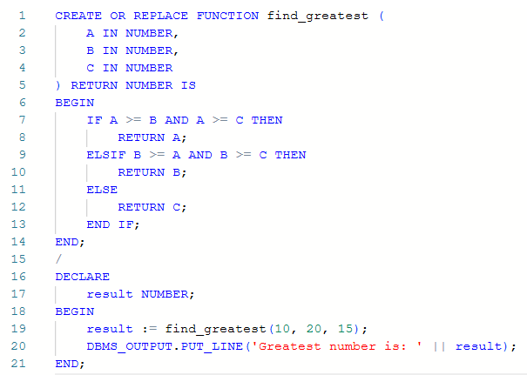

OUTPUT -

Q2 –

INPUT-

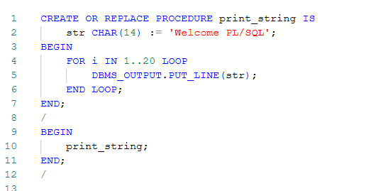

OUTPUT –

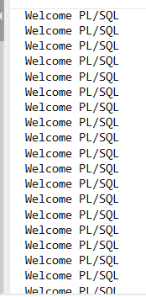

Q3 –

INPUT –

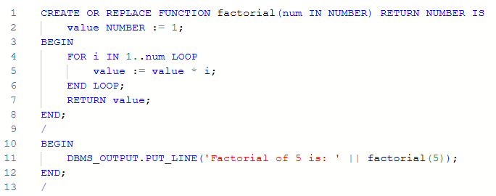

OUTPUT –

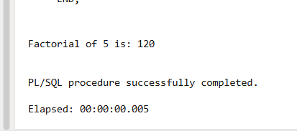

Q4 –

INPUT-

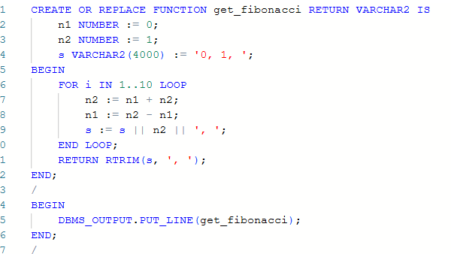

OUTPUT-

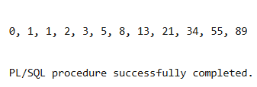

Q5-

INPUT –

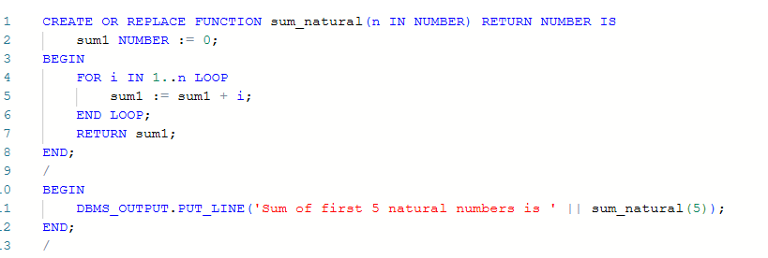

OUTPUT –

